Playback video for MDR:
- Download playback (MDVR player) from http://213.171.205.209:8080/808gps/login.html
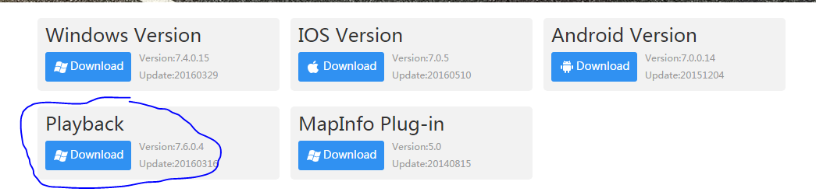

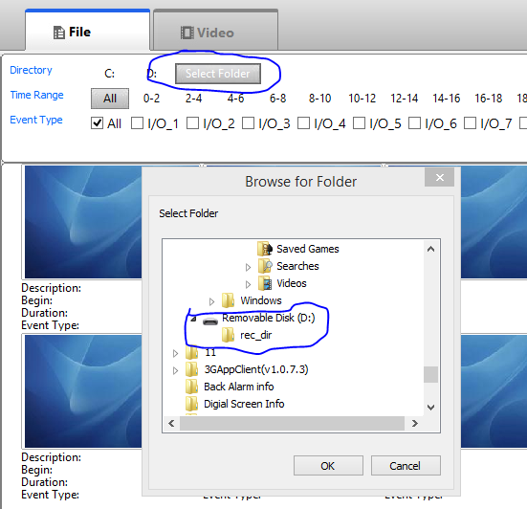
- Connect SD Card/HDD to PC and confirm which drive it is (D, E or F).
- Open MDVR player and select folder and search for SD or HDD.
- Click on the triangle next to it, a folder called ‘rec_dis’ should drop down which you should click on.
- After this files will be searching (can take a few minutes).

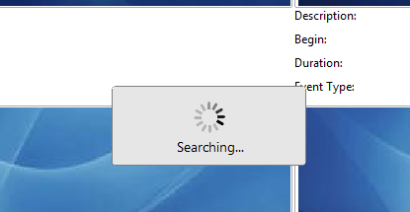

- Select date from the calendar and this will display recordings in the timeline below.
- Double click a certain time on the timeline and this will show the video recording at the time.

How to categorise into dates/folders:

- Click ‘my computer’ and select the hard drive attached i.e. E: or F:
- Double click on ‘rec_dir’ where you will find the following:
- Recordings/files on Hard drive:
- R20170531-060115NMD25O7F_lj16ebz.264

File format description:
- R = Recording-date YYYYMMDD-TIME 06-01-15am
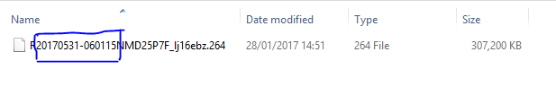
- N = Normal
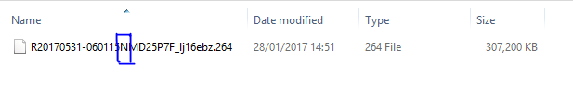
- M = Mainstream
- D25 = D1 recording 25fps
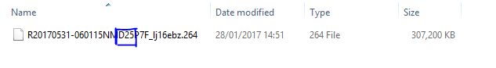
- P = Pal
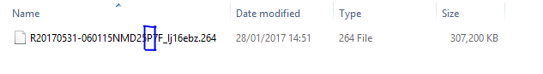
- 7F = Video Channel Mask
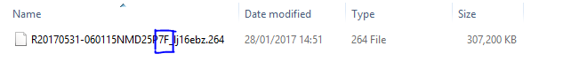
- Vehicle Registration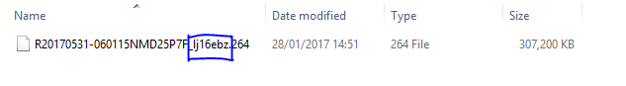
- Categorise folders into dates and make a new folder of the date interested i.e. ‘ 05-31’ as this is the day and month shown below.
- Move all spare files from the date ’05-31’ to the folder.
- All separate folders are different days and can be viewed day by day.

How to save selected footage:
- Click on AVI converter.
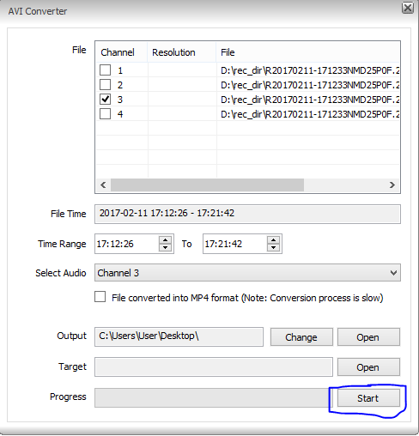
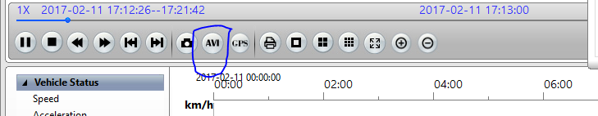

- Unselect the channels you don’t want.
- Change time range to the one of interest.
- Change output to desktop (or wherever you want the file to be saved).
- Leave target as blank and then start progress.
- Should show “AVI conversion successful”.
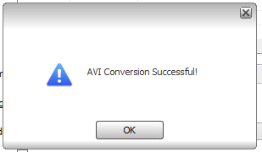

- File should be saved on desktop
- Double click the video file to play it.
- If an error persists download VLC media player.

- Download link for VLC media player is on Neatcom under links. 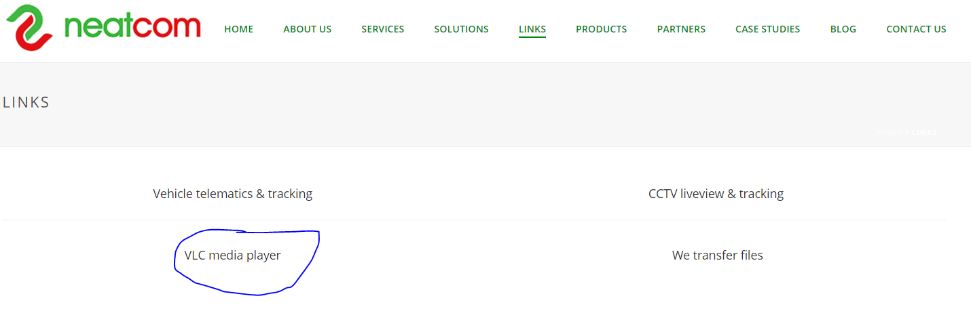
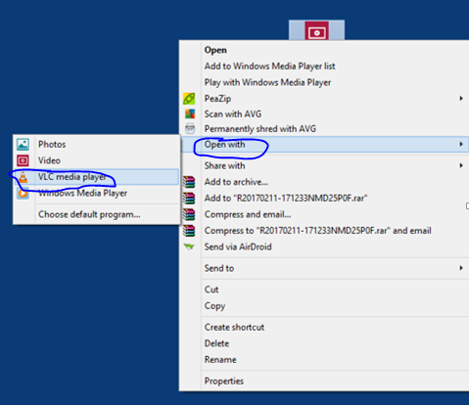
- After this has downloaded go on the video file, right click and then on open with VLC media player.
- The selected footage should be saved and viewable at choice from here on.

